Website User Guide

1. Register – How to Register?
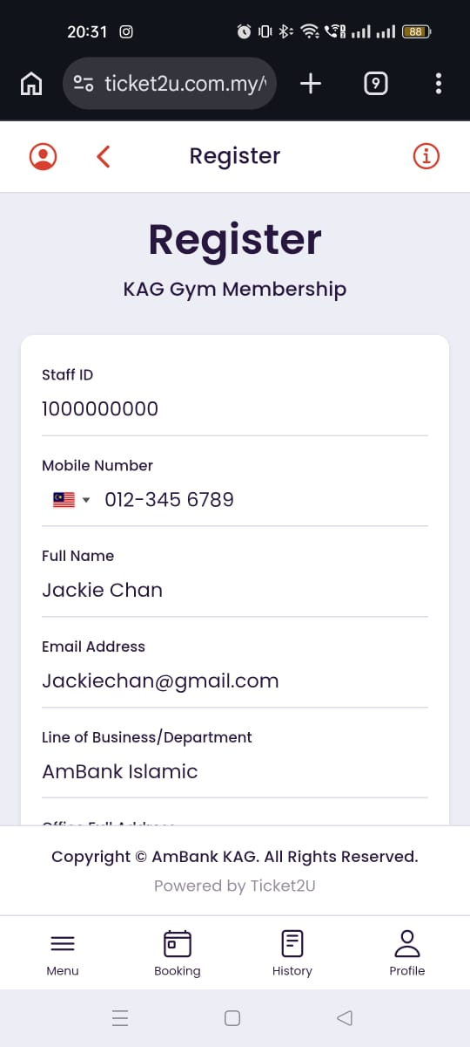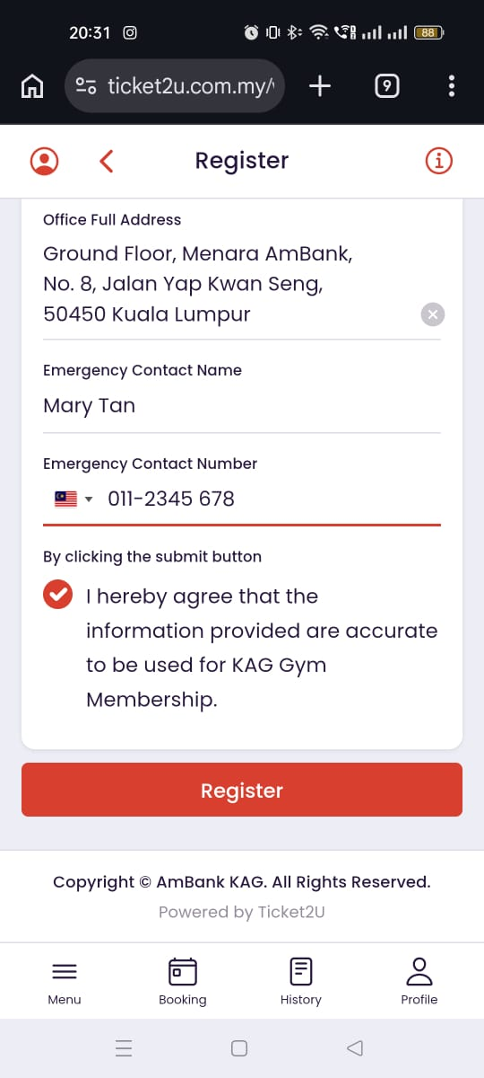

Follow the steps below to register a new account:
1. Fill in your personal details:
- Staff ID: Enter your company staff ID.
- Mobile Number: Enter your active mobile phone number (used to receive OTP verification).
- Full Name: Enter your full official name.
- Email Address: Enter your active company or personal email address.
- Line of Business / Department: Enter your department or business unit (e.g., IT, Finance, Operations).
- Office Full Address: Enter your office's full address.
- Emergency Contact Name: Enter the full name of your emergency contact person.
- Emergency Contact Number: Enter the active phone number of your emergency contact person.
2. Declaration / Agreement: Tick the checkbox to confirm and agree that the information provided is accurate for KAG Gym Membership.
3. Click the Register button to submit.
Note: If you have already registered, please go directly to the Login page: https://www.ticket2u.com.my/v3/kag/login

2. Login – How to Log In?
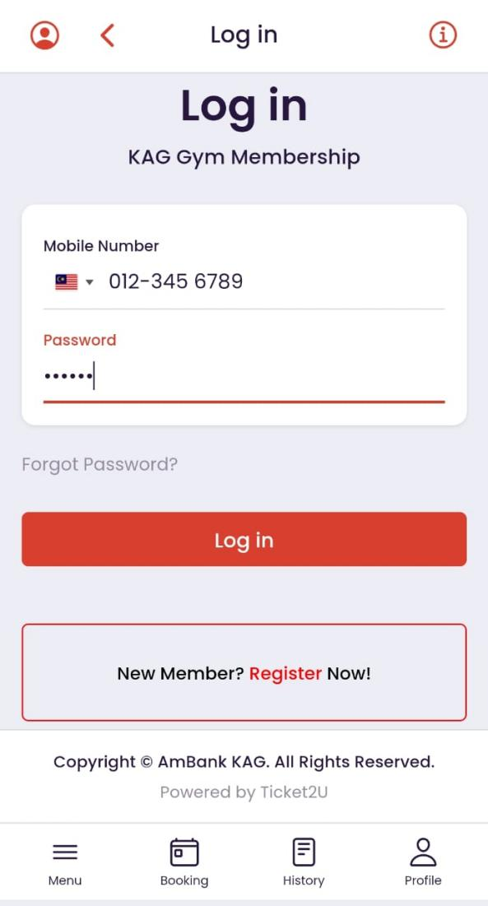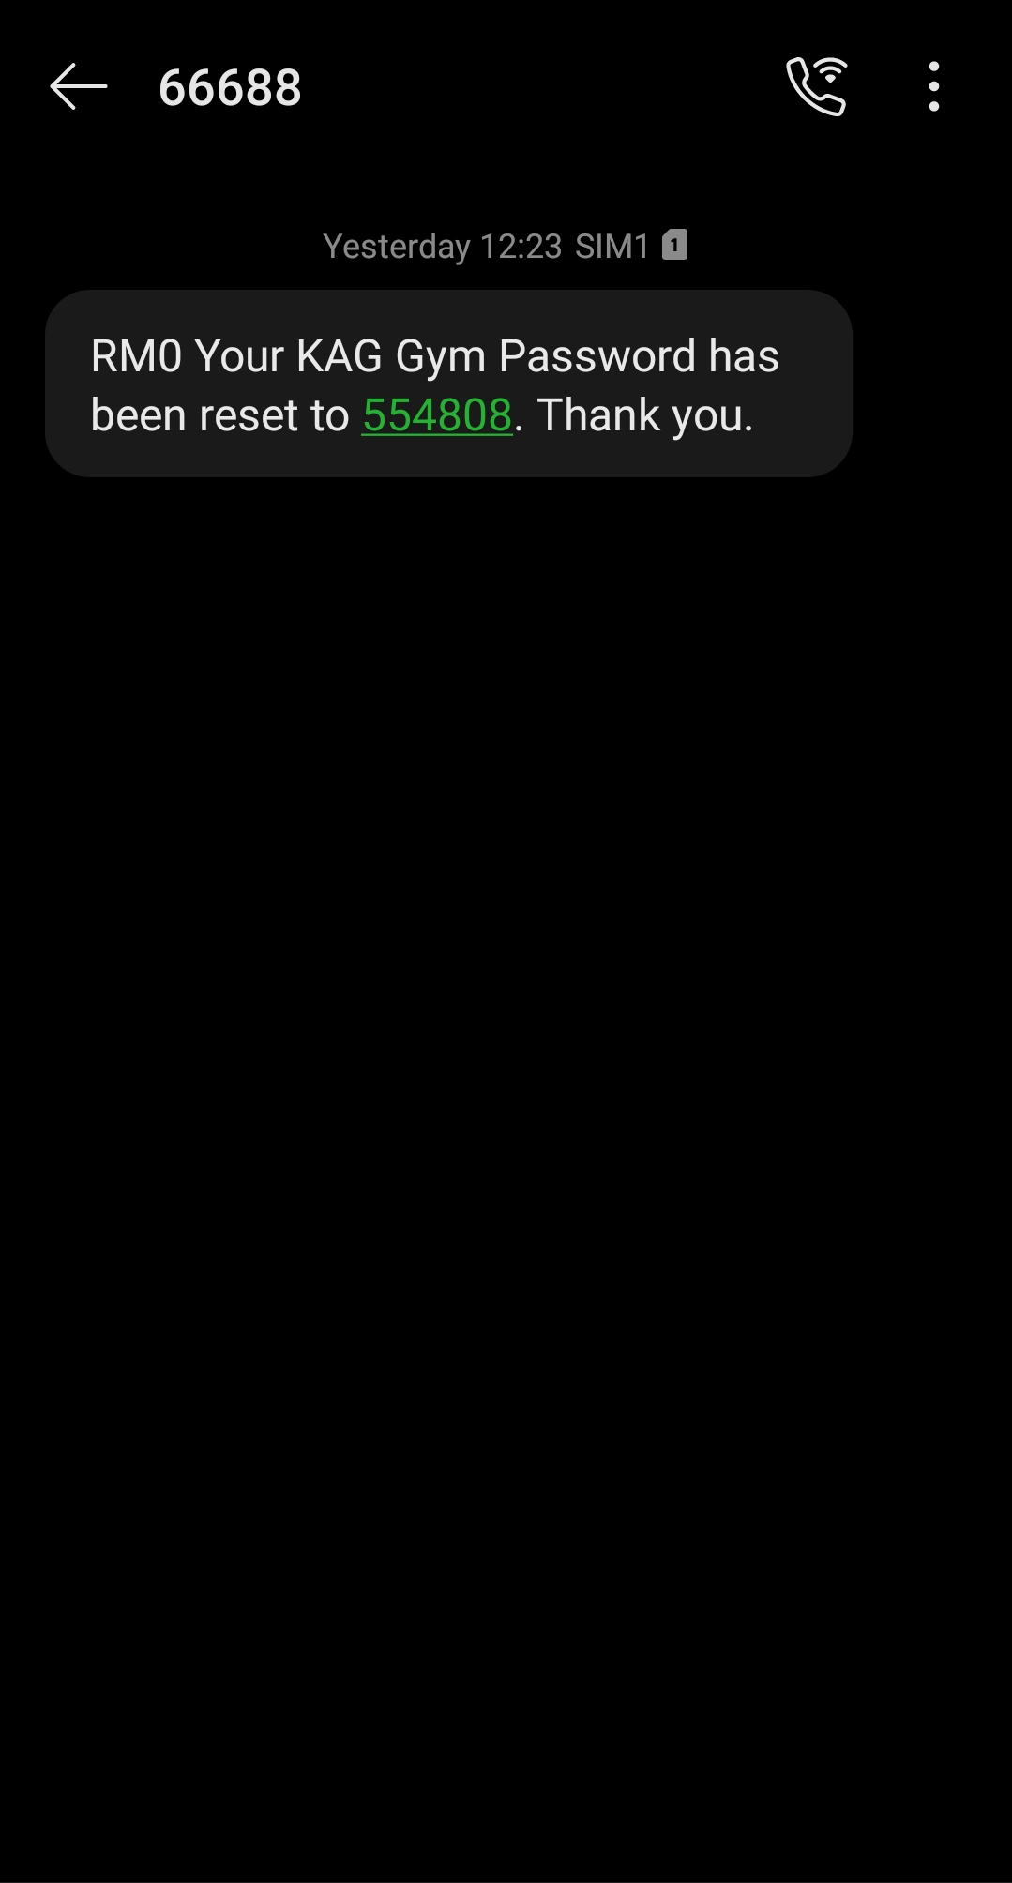

Follow the steps below to log in to your account:
1. Mobile Number: Enter the mobile phone number you used during registration.
2. Password: Enter your password.
- Note: After successful registration, a 6-digit password/OTP will be sent to your mobile phone via SMS (from 66688). Please keep this password secure for future logins.
3. Click Log in.
Note: If you do not have an account yet, click New Member? Register Now! or visit: https://www.ticket2u.com.my/v3/kag/register

3. Facial Registration – How to Set Up Facial ID
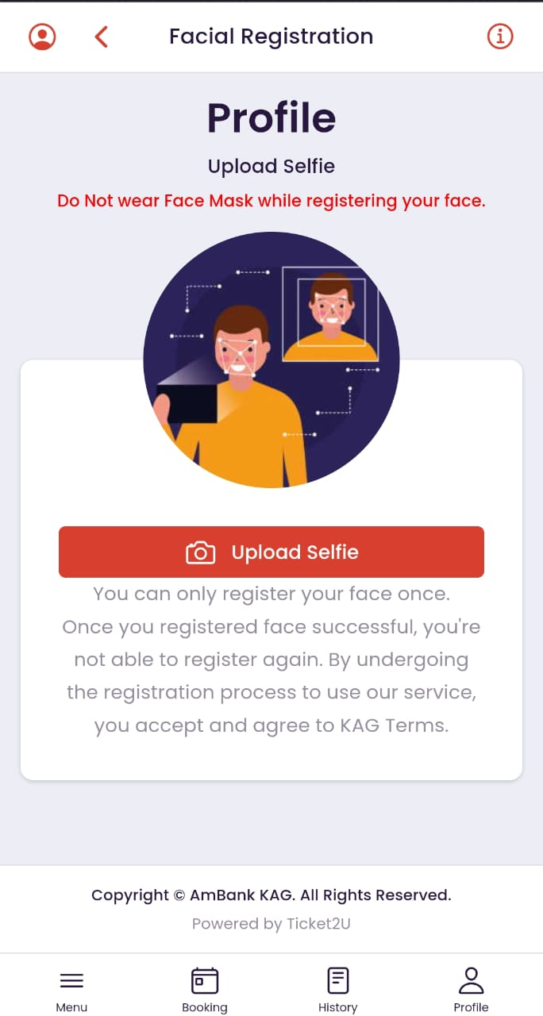

Follow the steps below to register your Facial ID for gym check-in:
1. Tap Upload Selfie to open your device camera.
2. Ensure you are in a well-lit environment and face the camera directly.
3. Important Guidelines:
- Do NOT wear a face mask or sunglasses while registering.
- Please take a clear photo of your own face, as this image will be used for entry recognition at the gym.
- One-time registration: You can only register your face once. Once registered successfully, you are not able to register again.
4. Submit the photo to activate facial recognition.

4. Purchase / Renew Membership – How to Make Payment
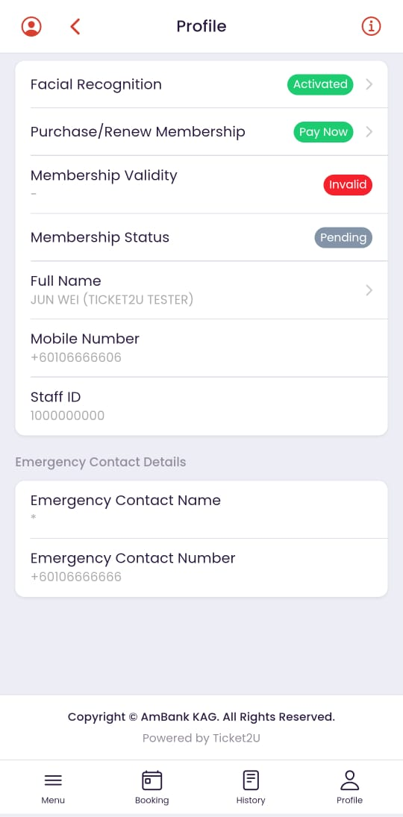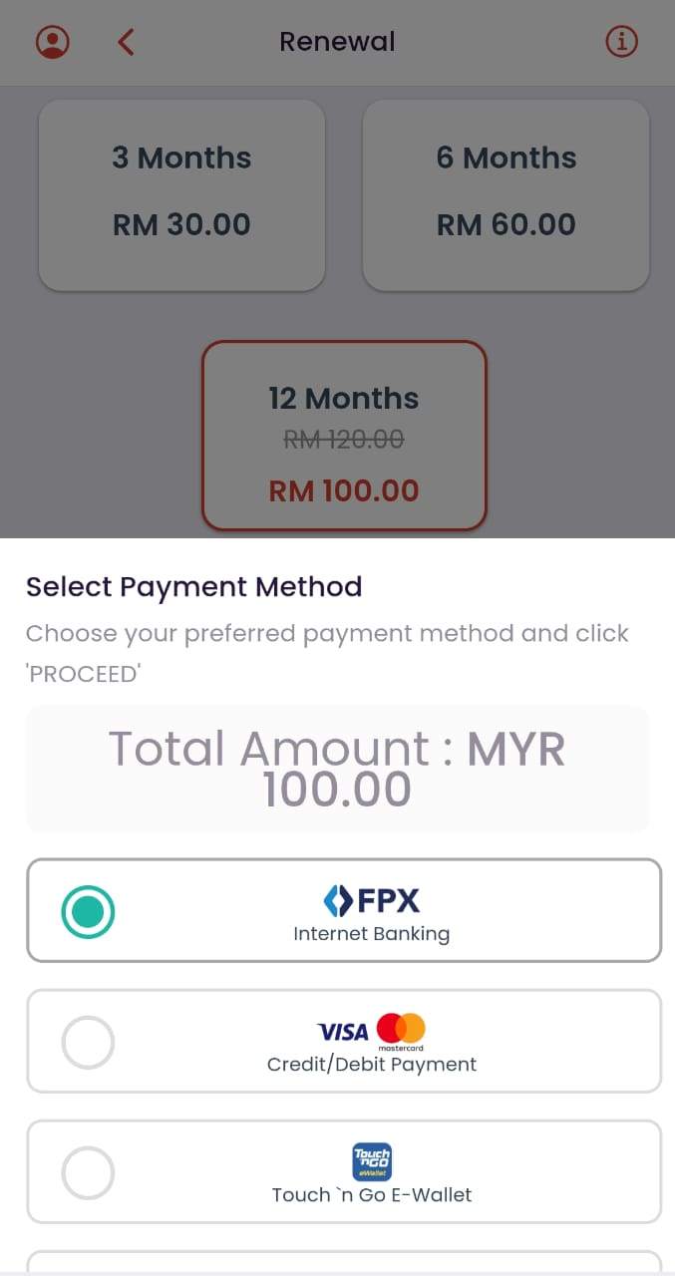

Follow the steps below to purchase or renew your membership:
1. Pre-requisite: Ensure your Facial Recognition status shows Activated on your Profile page.
2. Tap the Purchase/Renew Membership (or Pay Now) button.
3. Select your preferred membership plan (e.g., 3 Months - RM30, 6 Months - RM60, or 12 Months - RM100).
4. Select your preferred payment method:
- FPX (Internet Banking)
- Credit / Debit Card (Visa / Mastercard)
- Touch 'n Go e-Wallet
5. Complete the transaction via the payment gateway.
6. Once payment is successful, your Membership Status will become active, and you can begin booking gym slots.

5. Gym Booking – How to Book a Gym Slot
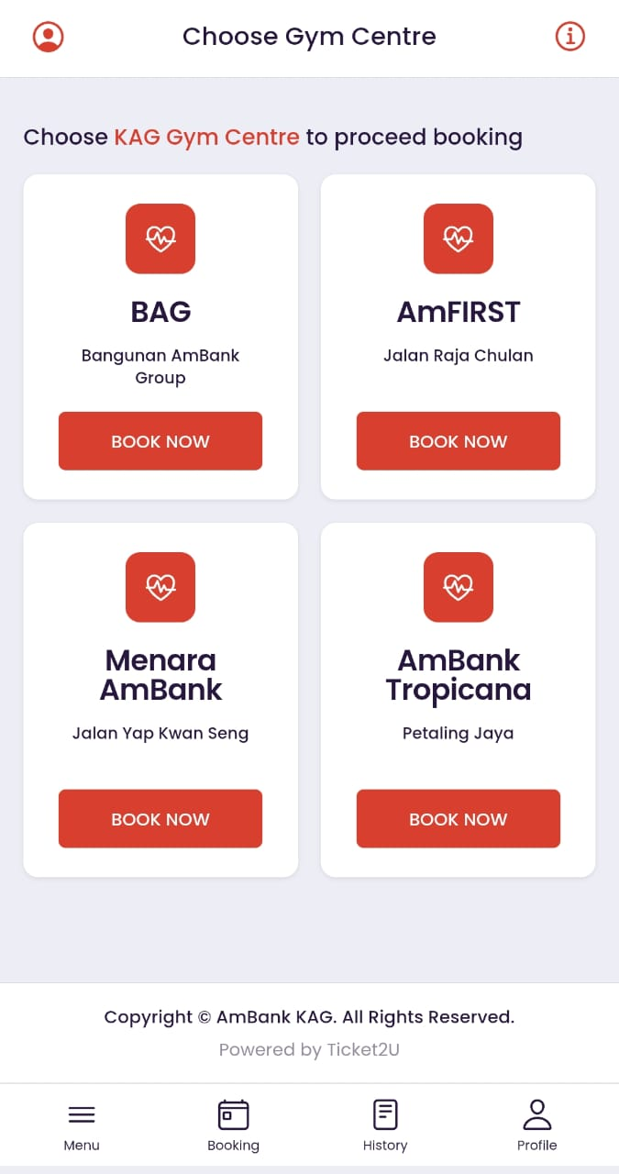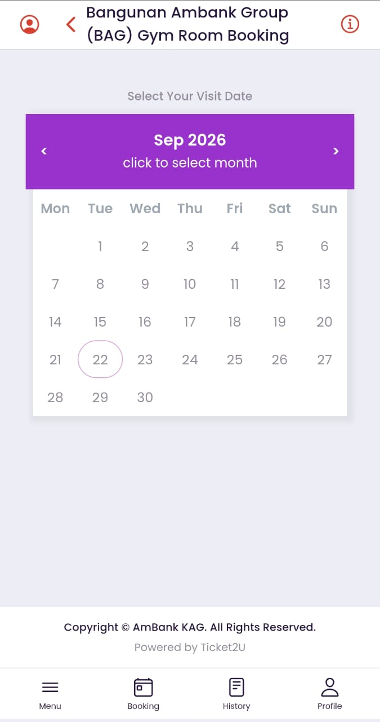

Follow the steps below to book a gym session:
1. Tap the Booking tab from the bottom navigation bar.
2. Choose your preferred gym center (e.g., BAG, AmFIRST, Menara AmBank, or AmBank Tropicana) and tap Book Now.
3. Select your preferred date from the calendar.
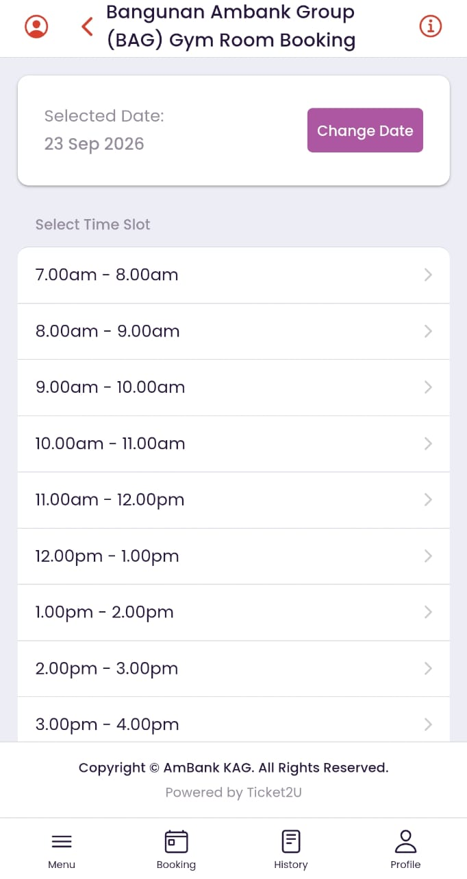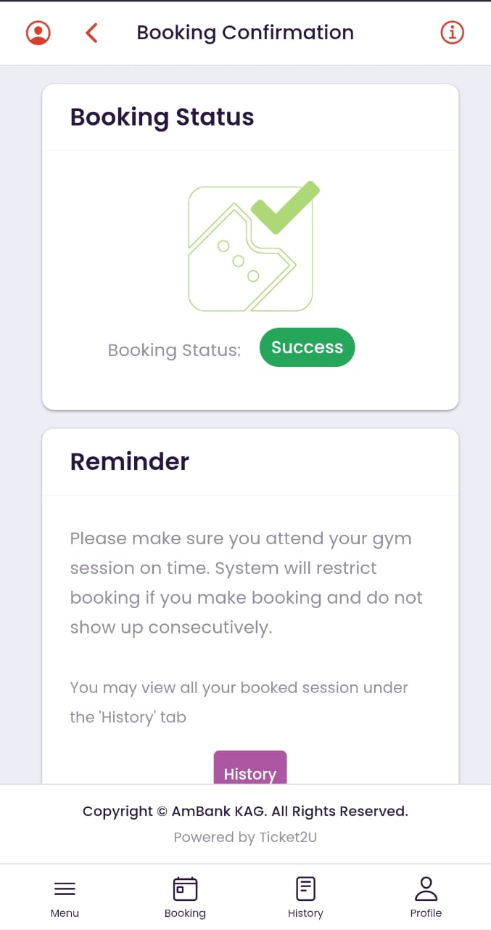

4. Select an available time slot (e.g., 7.00am - 8.00am, 12.00pm - 1.00pm).
5. Tap the Book button to confirm your reservation.
6. A Booking Confirmation screen will appear with a green Success badge.
7. You may tap the History button to view your booked session.

6. History – How to Check and Manage Bookings
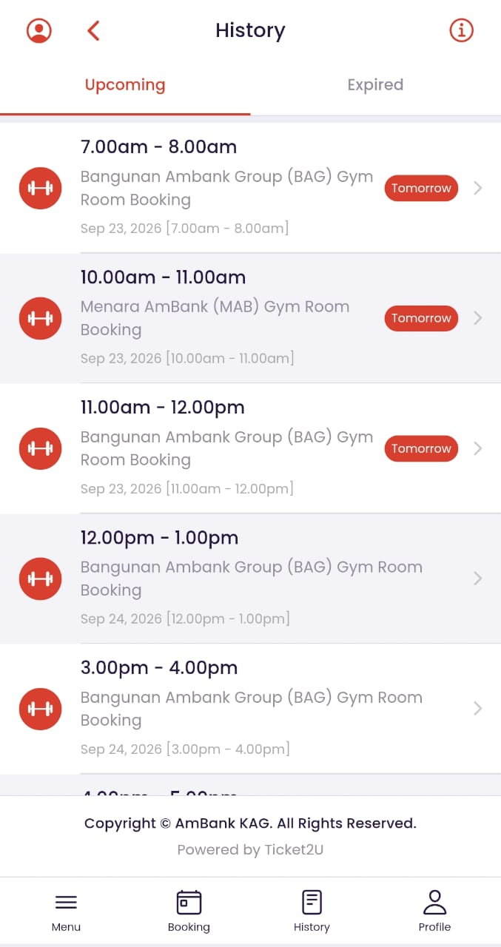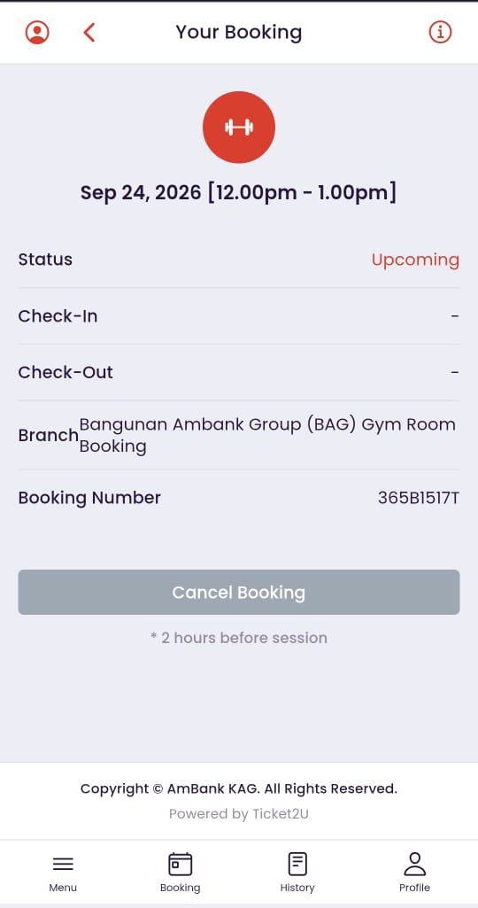

Follow the steps below to view or cancel your gym bookings:
1. Tap the History tab from the bottom navigation bar.
2. View your sessions under the Upcoming or Expired tabs.
3. Tap on any upcoming session to view the booking details (Status, Check-In/Out times, Branch, and Booking Number).
4. How to Cancel a Booking:
- If you are unable to attend, tap the Cancel Booking button.
- Notice: Cancellations must be made at least 2 hours before the session starts.
- Once canceled, you will not be able to check in using that booking number. You can re-book another available slot for the same day if needed.

7. Feedback – How to Submit Feedback
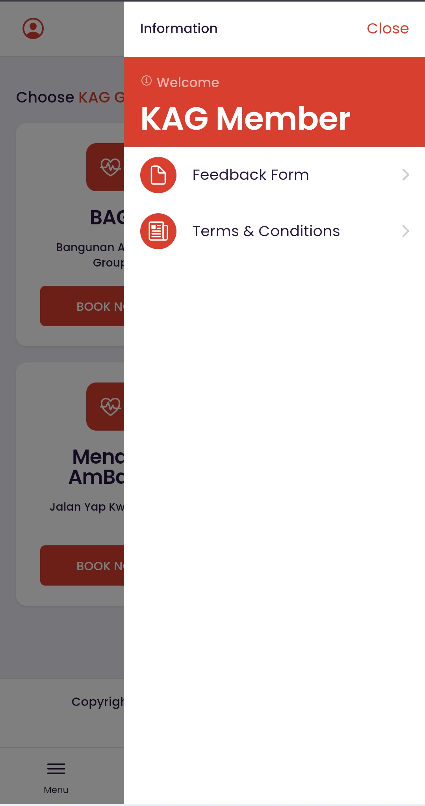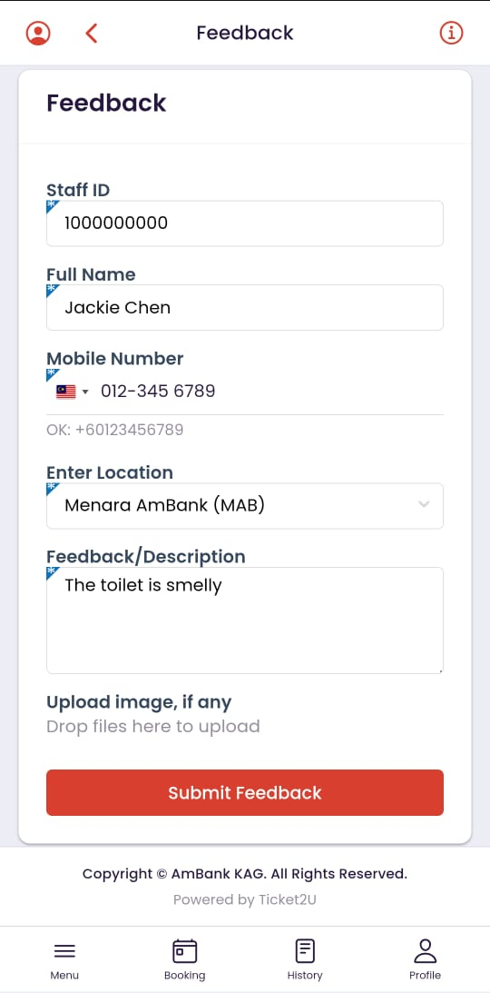

Follow the steps below to submit feedback, report a facility issue, or suggest improvements:
1. Tap the Menu icon on the bottom navigation bar and select Feedback Form.
2. Verify your personal details (Staff ID, Full Name, and Mobile Number).
- Please ensure your contact number is active so the management can follow up with you if needed.
3. Select your gym Location from the dropdown.
4. Enter your comments in the Feedback / Description box.
5. Tap Upload image to attach a photo if applicable (e.g., equipment condition).
6. Tap Submit Feedback to send.

8. Terms & Conditions – How to View Terms & Conditions

Follow the steps below to view the official Terms & Conditions:
1. Tap the Menu icon on the bottom navigation bar.
2. Select Terms & Conditions to view the full gym rules and member policy.
3. Members are advised to read and adhere to all facility guidelines and regulations displayed on the page before using the gym facilities.

